Application of Computer Vision and machine learning techniques to design and develop a Personalized Fashion Recommendation System for Females Aged 15–25 in Nepal
Introduction
“Fashion is not just about clothes. It’s about identity, emotion, and belonging.” This sentiment resonates deeply among young women in Nepal, where fashion operates as a socio-cultural language a means of expressing modernity, tradition, individuality, and community all at once. For Nepali females aged between 15 and 25, fashion is more than functional; it is aspirational.
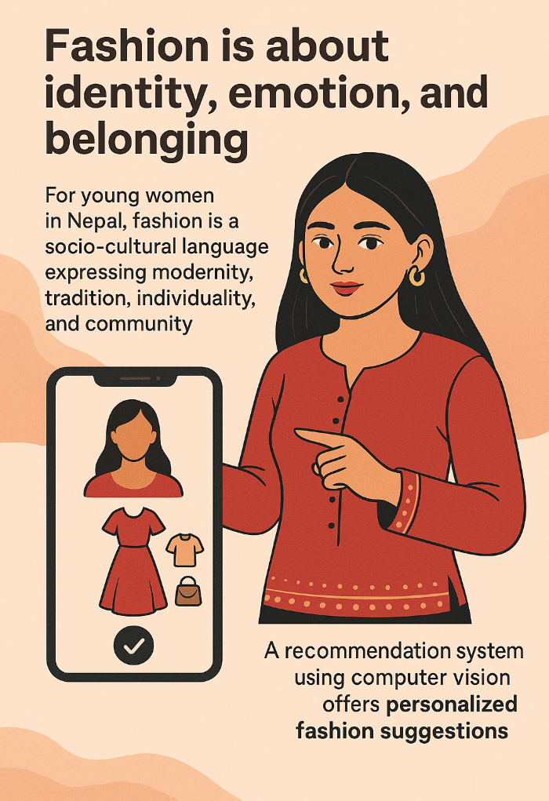
However, despite this emotional and social investment in clothing, the tools to support young women in making confident, personalized fashion choices are notably absent in the local market. In global contexts, computer vision has already revolutionized fashion through automated outfit matching, virtual try-ons, and personalized suggestions. Yet, in Nepal, most e-commerce and fashion discovery tools still rely on generic catalogs, manual filters, and poor personalization. These inefficiencies not only waste time but also fail to reflect the personal, body-based, and cultural preferences of users.
This project seeks to use computer vision to build a recommendation system that analyzes user-uploaded images (body features, skin tone, facial geometry) and suggests personalized fashion items that are both stylish and contextually appropriate. In doing so, it addresses both a technological gap and a psychological one helping users make faster, more satisfying fashion decisions in a sea of overwhelming choices.
Aim
Design and develop a computer vision-based fashion recommendation system for females aged 15–25 in Nepal that provides personalized clothing suggestions based on physical attributes and cultural relevance.
Objectives
- To study and understand the fashion preferences and consumption behavior of young women aged 15–25 in Nepal.
- To explore and analyze how computer vision is being used in the global fashion industry. And investigate the availability, limitations, and potential of existing computer vision-based fashion datasets and tools.
- To design and develop a prototype system that utilizes computer vision for personalized fashion recommendations.
- To test and refine the prototype with user feedback, focusing on functionality, usability, and relevance.
- To document the entire process and submit a comprehensive report outlining findings, challenges, and future improvements.
Justification
This project is justified on both technical and economic grounds. From a technical standpoint, the integration of computer vision into fashion for young Nepali females addresses an unmet market need for personalized digital shopping tools. The local market lacks systems that account for unique physical traits, cultural dress preferences, and fashion consciousness driven by social media.
From an economic perspective, this project aligns with utility theory, which argues that consumers make choices to maximize personal satisfaction. Personalized recommendation systems powered by Artificial Intelligence (AI) are shown to increase perceived utility, enabling consumers to find clothes that fit their preferences more accurately and reduce buyer’s remorse. Additionally, bounded rationality introduced by Herbert Simon suggests that users do not have infinite cognitive resources to process every available option. In the absence of intelligent guidance, people make suboptimal decisions based on limited information.
This phenomenon is exacerbated by the paradox of choice, a concept in behavioral economics which argues that an excess of options leads to decision fatigue and dissatisfaction. Most online shopping platforms overload users with hundreds of items, none of which are tailored. A personalized recommendation system mitigates this issue by narrowing the selection intelligently, increasing efficiency and satisfaction.
The Dunning-Kruger Effect is also relevant in this context. This cognitive bias suggests that individuals with limited fashion knowledge may overestimate their ability to make good clothing choices, leading to dissatisfaction and inefficiency. A recommendation system can serve as a corrective mechanism, guiding users with less fashion literacy toward more appropriate and satisfying selections.
Furthermore, the project can be viewed through the lens of social contract theory. Users are implicitly entering into a digital agreement with the platform sharing personal data (images, preferences) in exchange for meaningful value (better recommendations). This highlights the ethical responsibility of the system designers to uphold transparency, fairness, and cultural sensitivity in all algorithmic decisions, honoring the "contract" between user and technology.
Nonetheless, one might argue that algorithmic fashion tools could promote uniformity or reinforce narrow beauty standards. This is a valid concern but can be mitigated by intentionally training models on diverse datasets representing various body types, skin tones, and styles typical of Nepali women. Furthermore, by involving real users during prototype testing and feedback cycles, the system will adapt based on localized, real-world preferences rather than global defaults.
Another concern lies in confirmation bias, where users may only accept fashion suggestions that confirm their pre-existing beliefs or aesthetic tastes. To counter this, the algorithm can occasionally introduce subtle novelty and diversity in its recommendations, nudging users toward broader self-discovery a known technique in choice architecture from behavioral economics.
Moreover, fashion in Nepal is embedded in tradition and modesty, especially in certain communities. A system trained exclusively in Western fashion data might unintentionally recommend outfits that are culturally insensitive. Thus, ethical design and bias-aware training are key priorities in this project.
Research Questions
- What are the current fashion behaviors, expectations, and frustrations of young females aged 15–25 in Nepal, and how can computer vision technologies be adapted to address them and how can a personalized fashion recommendation system be effectively designed, implemented, and validated using computer vision and iterative feedback?
- What ethical challenges (e.g., privacy, cultural misalignment, body image sensitivity) emerge from deploying such a system, and how can they be responsibly mitigated?
Literature Review
Desk based research methodology
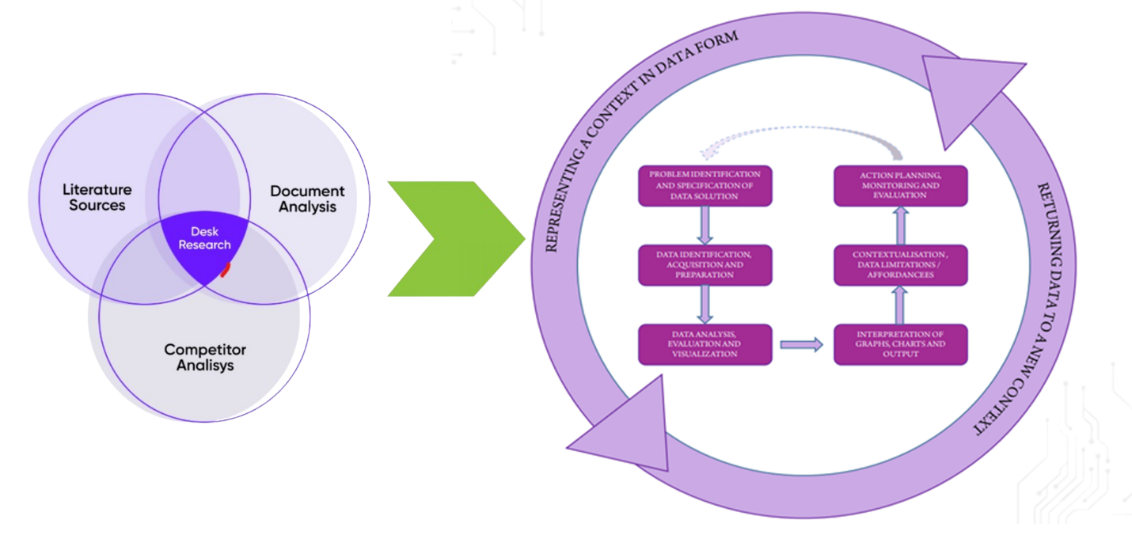
The proposed research will employ a desk-based methodology grounded in the principles of Agile development and Design Thinking. Agile provides a cyclical framework involving research, prototyping, testing, and refinement ideally suited for building and iterating digital products. Given time constraints and limited physical access to users, a desk-based method allows the researcher to review existing academic literature, online datasets, market trends, and related technologies.
This approach will support continuous evaluation, allowing for multiple iterations of the computer vision pipeline from feature detection to recommendation logic. Each cycle will include theoretical review, technical testing, and reflective analysis. User experience design will be informed by literature on cognitive load, visual complexity, and fashion psychology.
Case studies
In the broader literature, numerous commercial and academic examples reveal how computer vision is transforming fashion. Zalando and Amazon, for instance, have built systems that use deep learning to recommend outfits based on uploaded photos. Similarly, virtual try-on apps like L’Oréal’s Modiface and Warby Parker’s AR-based eyeglass try-ons show how body or face recognition can enhance personalization.
However, these systems are largely designed for Western audiences and often fail to consider cultural variance. Nepal’s fashion culture is shaped by modesty, festival wear, ethnic clothing, and economic factors, none of which are prioritized in global models. This project thus represents both an academic contribution and a localized innovation.
Other industries have similarly adapted computer vision for contextual personalization. In healthcare, facial symmetry and skin analysis are used for dermatological diagnoses. In education, posture and eye-tracking technologies inform adaptive learning interfaces. These examples validate the use of visual features for tailored services providing a theoretical and technological backbone for this research.
Integration
The prototype system will integrate multiple layers of technology. First, image processing will be handled using OpenCV and MediaPipe, which allow for pose estimation and facial recognition. These tools will extract features such as skin tone, facial geometry, and body shape. This information will be fed into a TensorFlow-based neural network trained on curated fashion datasets that combine global and local images to ensure cultural fit.

A recommendation engine will be built using a combination of clustering algorithms (e.g., k-means for style grouping) and similarity measures (e.g., cosine similarity) to match user profiles with fashion templates. Data will be annotated with labels reflecting style, formality, occasion, season, and modesty.
For front-end interaction, the system will be deployed as a mobile-first web app using Flutter or React, allowing users to upload photos and receive outfit suggestions in real-time. Feedback will be collected through embedded surveys and passive interaction analytics. An admin dashboard will allow tracking of model decisions to ensure transparency and offer explainability.
Finally, the project will implement bias auditing tools to assess output diversity and fairness. Open-source fairness frameworks such as IBM AI Fairness 360 may be integrated to continuously monitor recommendation patterns across user attributes.
Conclusion
This project offers a timely and contextually relevant intervention in the intersection of fashion, technology, and personalization. By developing a computer vision-powered recommendation system tailored for young Nepali women, it aspires not only to solve a market gap but also to explore how AI can be made culturally responsive and ethically aligned. The proposal acknowledges limitations, including potential data scarcity, representational bias, and ethical challenges. Yet, through desk-based agile development, ethical design, and inclusive modeling, the project aims to contribute both academically and practically to the growing discourse on responsible AI in consumer spaces.

References
- Wang, X., Zhang, Y., & Liu, H. (2022). Computer Vision in Fashion: A Survey. Journal of Visual Communication and Image Representation.
- Thaler, R., & Sunstein, C. (2009). Nudge: Improving Decisions About Health, Wealth, and Happiness. Penguin.
Appendix
Swot analysis
Strengths  Interest in personal fitness and how technology can make it more efficient | Weaknesses  First time conducting such research project
Opportunities  Get good grades and learn something | Threats  Unable to complete the project in time

Risk Log
Id | Name | Occurrence | Impact | Plan B
1 | Health issues | frequent | low | Be careful
2 | Knowledge base | Very frequent | fatal | Study more
3 | Computing power | Rare | low | Request for computing from college
4 | Other modules | often | high | Create a schedule

Project plan

